Hands-on Lab: Dimensional Modelling with Medallion Architecture in Snowflake
Build the SALES star schema (PRODUCT, PERIOD, STORE dimensions plus a SALES fact) through Bronze, Silver and Gold layers.

1. What you will build

Layer | Schema | Purpose | What you do in this lab
Bronze | BRONZE | Raw data, as received | Load messy source data as strings with load metadata
Silver | SILVER | Cleaned, typed, deduplicated | Trim, standardise case, cast types, remove duplicates, reject bad rows
Gold | GOLD | Business-ready dimensional model | Build DIM_PRODUCT, DIM_PERIOD, DIM_STORE and FACT_SALES
Flow: Raw sources -> BRONZE -> SILVER -> GOLD star schema -> BI queries

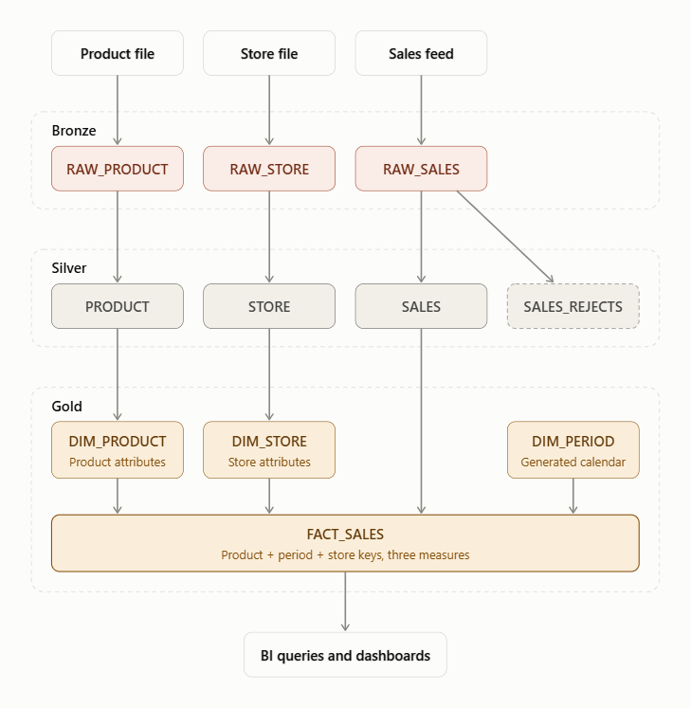
Prerequisites: a Snowflake account (a trial works) and a Snowsight worksheet. Run each block in order.

2. Step 0: Set up the environment
USE ROLE SYSADMIN;
CREATE WAREHOUSE IF NOT EXISTS LAB_WH
WAREHOUSE_SIZE = 'XSMALL'
AUTO_SUSPEND = 60
AUTO_RESUME = TRUE
INITIALLY_SUSPENDED = TRUE;
USE WAREHOUSE LAB_WH;
CREATE DATABASE IF NOT EXISTS DIM_LAB;
CREATE SCHEMA IF NOT EXISTS DIM_LAB.BRONZE;
CREATE SCHEMA IF NOT EXISTS DIM_LAB.SILVER;
CREATE SCHEMA IF NOT EXISTS DIM_LAB.GOLD;

3. Step 1: Bronze layer (raw, as-is)
Bronze keeps data exactly as it arrives. Every business column is a STRING so nothing fails on load, and we add audit columns. The sample data is deliberately dirty: mixed case, extra spaces, duplicates, a bad date, and a missing number.
USE SCHEMA DIM_LAB.BRONZE;
-- Product source
CREATE OR REPLACE TABLE RAW_PRODUCT (
PRODUCT_CODE STRING, DESCRIPTION STRING, COLOR STRING, SIZE STRING,
_LOADED_AT TIMESTAMP_NTZ DEFAULT CURRENT_TIMESTAMP(),
_SOURCE STRING DEFAULT 'lab_insert'
);
INSERT INTO RAW_PRODUCT (PRODUCT_CODE, DESCRIPTION, COLOR, SIZE) VALUES
('P001', 'T-Shirt', 'Red', 'M'),
('p002 ', 'hoodie', 'Blue', 'L'),
('P003', 'Jeans', 'Black', '32'),
('P003', 'Jeans', 'Black', '32'), -- duplicate
('P004', 'Cap', ' green', 'S');
-- Store source
CREATE OR REPLACE TABLE RAW_STORE (
STORE_CODE STRING, STORE_NAME STRING, CITY STRING, TELEPHONE STRING, MANAGER STRING,
_LOADED_AT TIMESTAMP_NTZ DEFAULT CURRENT_TIMESTAMP(),
_SOURCE STRING DEFAULT 'lab_insert'
);
INSERT INTO RAW_STORE (STORE_CODE, STORE_NAME, CITY, TELEPHONE, MANAGER) VALUES
('S01', 'Downtown Store', 'Hyderabad', '040-1111', 'Asha'),
('s02 ', 'Airport Mall', 'Bengaluru', '080-2222', 'Ravi'),
('S03', 'Lakeside', 'Chennai', '044-3333', NULL);
-- Sales transactions source
CREATE OR REPLACE TABLE RAW_SALES (
PRODUCT_CODE STRING, SALE_DATE STRING, STORE_CODE STRING,
UNITS_SOLD STRING, DOLLARS_SOLD STRING, DOLLARS_COST STRING,
_LOADED_AT TIMESTAMP_NTZ DEFAULT CURRENT_TIMESTAMP(),
_SOURCE STRING DEFAULT 'lab_insert'
);
INSERT INTO RAW_SALES (PRODUCT_CODE, SALE_DATE, STORE_CODE, UNITS_SOLD, DOLLARS_SOLD, DOLLARS_COST) VALUES
('P001', '2026-01-15', 'S01', '10', '200.00', '120.00'),
('p002 ', '2026-01-15', 'S02', '5', '250.00', '150.00'),
('P003', '2026-02-10', 'S01', '3', '180.00', '90.00'),
('P003', '2026-02-10', 'S01', '3', '180.00', '90.00'), -- duplicate
('P004', '2026-02-20', 'S03', '20', '300.00', '160.00'),
('P001', '2026-03-05', 'S02', '8', '160.00', '96.00'),
('P002', '2026-03-18', 'S03', '4', '200.00', '120.00'),
('P004', 'not-a-date', 'S01', '2', '30.00', '16.00'), -- bad date
('P001', '2026-03-20', 'S01', NULL, '50.00', '30.00'); -- missing units
SELECT 'RAW_PRODUCT' AS tbl, COUNT(*) AS cnt FROM RAW_PRODUCT
UNION ALL SELECT 'RAW_STORE', COUNT(*) FROM RAW_STORE
UNION ALL SELECT 'RAW_SALES', COUNT(*) FROM RAW_SALES;
Expected counts: 5, 3 and 9.
In real projects Bronze is populated with COPY INTO from a stage not INSERT statements. The layer design stays the same.

4. Step 2: Silver layer (cleaned and conformed)
Silver applies the rules: trim and upper-case keys, standardise text, cast to proper types with TRY_ functions, keep the latest record per business key, and send unusable rows to a rejects table.
Your task: write the SQL yourself, one table at a time, using the steps and hints below. Work inside the DIM_LAB.SILVER schema (run USE SCHEMA DIM_LAB.SILVER; first). Create each table with CREATE OR REPLACE TABLE ... AS SELECT (CTAS), so you can re-run a step safely.
- Build SILVER.PRODUCT from BRONZE.RAW_PRODUCT.
  - Clean the key: remove stray spaces and force upper case so 'p002 ' becomes P002. Hint: TRIM and UPPER.
  - Tidy the text columns (description, colour) so they are consistently capitalised. Hint: INITCAP.
  - Keep one row per product code, the most recently loaded one. Hint: ROW_NUMBER() OVER (PARTITION BY <cleaned key> ORDER BY _LOADED_AT DESC), then keep row number 1. Snowflake's QUALIFY clause filters on a window function without needing a subquery.
- Build SILVER.STORE from BRONZE.RAW_STORE.
  - Repeat the same pattern: clean the store code, tidy names and city, keep the latest row per store.
  - Replace a missing manager with a default such as Unassigned. Hint: COALESCE.
- Build SILVER.SALES from BRONZE.RAW_SALES.
  - Clean the product and store codes exactly as you did above, so they will match the dimensions later.
  - Convert the text columns to real types: a date, a whole number for units, and decimals for dollars. Hint: TRY_TO_DATE, TRY_TO_NUMBER(col, 12, 2). The TRY_ versions return NULL on bad input instead of failing the whole query.
  - Keep only rows where every converted value is NOT NULL. Hint: a WHERE clause that repeats the same conversions.
  - Remove duplicates using product code + sale date + store code as the business key, again with ROW_NUMBER and QUALIFY.
- Build SILVER.SALES_REJECTS (quarantine).
  - Select the original Bronze rows that failed the rules in step 3. Hint: reuse the same conversions, but test for NULL joined with OR instead of AND.
  - Stretch goal: add a REJECT_REASON column using CASE WHEN (for example, 'bad date' or 'missing units').
- Check your work. Count the rows in each Silver table with a UNION ALL of COUNT(*) queries, and compare against the expected counts below.
Why this design? Silver should never throw away data silently. Anything rejected goes to a quarantine table so a data steward can fix and replay it.
Expected counts: 4, 3, 6 and 2. The duplicate product and duplicate sale are removed, and the bad-date and missing-units rows are quarantined.

5. Step 3: Gold layer (the star schema from your diagram)
Gold: three dimensions and one fact.
Your task: build four tables in DIM_LAB.GOLD with exactly these names, because the validation and analytics queries in Steps 4 and 5 depend on them. Run USE SCHEMA DIM_LAB.GOLD; first.
Gold table | Built from | Key logic
DIM_PRODUCT | SILVER.PRODUCT | Primary key: PRODUCT_CODE
DIM_STORE | SILVER.STORE | Primary key: STORE_CODE
DIM_PERIOD | Generated, no source table | Primary key: PERIOD_CODE (YYYYMMDD)
FACT_SALES | SILVER.SALES + the three dimensions | Composite key: product, period, store
- Create DIM_PRODUCT.
  - Define the columns explicitly (PRODUCT_CODE, DESCRIPTION, COLOR, SIZE, all strings) rather than using CTAS, so you control the key. Hint: CREATE TABLE ... (col TYPE, ...) and mark the key column PRIMARY KEY.
  - Load it from SILVER.PRODUCT. Hint: INSERT INTO ... SELECT ....
- Create DIM_STORE the same way: STORE_CODE (primary key), STORE_NAME, CITY, TELEPHONE, MANAGER.
- Create DIM_PERIOD, a calendar generated by SQL. There is no source table, so you manufacture one row per day for Jan to Mar 2026 (90 rows).
  - Generate 90 sequential rows. Hint: TABLE(GENERATOR(ROWCOUNT => 90)) together with SEQ4().
  - Turn each row number into a date. Hint: DATEADD(day, SEQ4(), '2026-01-01'::DATE), ideally inside a CTE.
  - Derive PERIOD_CODE as the date written as YYYYMMDD and stored as a number. Hint: TO_CHAR(date, 'YYYYMMDD') then TO_NUMBER.
  - Derive YEAR, QUARTER, MONTH and DAY with the functions of the same names.
- Create FACT_SALES. The grain is one row per product, day and store.
  - Columns: PRODUCT_CODE, PERIOD_CODE, STORE_CODE, UNITS_SOLD, DOLLARS_SOLD, DOLLARS_COST (use NUMBER(12,2) for dollars).
  - Declare a composite PRIMARY KEY over the three key columns, plus three FOREIGN KEY ... REFERENCES clauses pointing at the dimensions. This is exactly what the crow's-foot lines in your diagram show.
  - Load it from SILVER.SALES. Convert SALE_DATE into PERIOD_CODE using the same YYYYMMDD formula as the dimension, otherwise the keys will not match.
  - Join to DIM_PRODUCT and DIM_STORE on their codes. An inner join acts as a safety net: a sale with an unknown product or store cannot enter the fact table.
- Check your work. Move on to Step 4. If an orphan or grain check returns rows, revisit the key formulas in step 4 first.
Snowflake does not enforce PRIMARY KEY or FOREIGN KEY constraints. They are informational, which helps BI tools and documents the model, so you must validate integrity yourself (next step).

6. Step 4: Validate the model
-- Row counts: expect 4, 3, 90, 6
SELECT 'DIM_PRODUCT' AS tbl, COUNT(*) AS cnt FROM DIM_PRODUCT
UNION ALL SELECT 'DIM_STORE', COUNT(*) FROM DIM_STORE
UNION ALL SELECT 'DIM_PERIOD', COUNT(*) FROM DIM_PERIOD
UNION ALL SELECT 'FACT_SALES', COUNT(*) FROM FACT_SALES;
-- Orphan check: each should return 0
SELECT COUNT(*) AS orphan_products FROM FACT_SALES f
LEFT JOIN DIM_PRODUCT p ON p.PRODUCT_CODE = f.PRODUCT_CODE WHERE p.PRODUCT_CODE IS NULL;
SELECT COUNT(*) AS orphan_periods FROM FACT_SALES f
LEFT JOIN DIM_PERIOD d ON d.PERIOD_CODE = f.PERIOD_CODE WHERE d.PERIOD_CODE IS NULL;
SELECT COUNT(*) AS orphan_stores FROM FACT_SALES f
LEFT JOIN DIM_STORE s ON s.STORE_CODE = f.STORE_CODE WHERE s.STORE_CODE IS NULL;
-- Grain check: should return no rows
SELECT PRODUCT_CODE, PERIOD_CODE, STORE_CODE, COUNT(*)
FROM FACT_SALES GROUP BY ALL HAVING COUNT(*) > 1;

7. Step 5: Query the star schema
-- Revenue and profit by month and city
SELECT
d.YEAR, d.QUARTER, d.MONTH,
s.CITY,
SUM(f.UNITS_SOLD) AS units,
SUM(f.DOLLARS_SOLD) AS revenue,
SUM(f.DOLLARS_SOLD - f.DOLLARS_COST) AS profit
FROM GOLD.FACT_SALES f
JOIN GOLD.DIM_PERIOD d ON d.PERIOD_CODE = f.PERIOD_CODE
JOIN GOLD.DIM_STORE s ON s.STORE_CODE = f.STORE_CODE
GROUP BY ALL
ORDER BY d.MONTH, s.CITY;
-- Top products by profit
SELECT p.DESCRIPTION, p.COLOR,
SUM(f.DOLLARS_SOLD - f.DOLLARS_COST) AS profit
FROM GOLD.FACT_SALES f
JOIN GOLD.DIM_PRODUCT p ON p.PRODUCT_CODE = f.PRODUCT_CODE
GROUP BY ALL
ORDER BY profit DESC;
Notice how simple the queries are: one fact, join to dimensions, group and aggregate. That is the payoff of dimensional modelling.

8. Clean up
USE ROLE SYSADMIN;
DROP DATABASE IF EXISTS DIM_LAB;
DROP WAREHOUSE IF EXISTS LAB_WH;

9. Key takeaways
- Bronze preserves the source untouched, so you can always reprocess.
- Silver is where quality rules live: types, trimming, deduplication, rejects.
- Gold is the business-facing star schema, modelled around facts (measures) and dimensions (context).
- Define the grain of the fact table first. Here it is one row per product, day and store.

